INTRODUCTION

This strategic plan updated as at April 2018 reflects the development in the strategic direction of the sport at both a national and regional level. This strategic planning is an ongoing process, which will be undertaken in conjunction with Basketball New Zealand’s ongoing direction and operational requirements.

For Southland basketball to be a successful, credible and vibrant regional sporting body we need to acknowledge what is and is not working for us.

SOUTHLAND BASKETBALL ASSOCIATION
Strategic Plan 2018 - 2021
We must build and maintain our momentum to provide an environment where our game becomes a sport people want to be involved with. In order to achieve this we need a unified shared vision and a plan of how we intend to get there.

POSITIONING STATEMENT

The following strategic overview and core strategic objectives endeavor to align to Basketball New Zealand’s key strategic goals.
SOUTHLAND BASKETBALL ASSOCIATION
Strategic Plan 2018 - 2021

Purpose

As the sole provider of basketball services, SBA will encourage healthy active lifestyles, provide development pathways for all (players, coaches, referees and officials) and contribute proactively to basketball in New Zealand.

To operate an effective, well organised business enabling increased participation and ensuring highest levels of opportunity for all players, referees, officials and coaches to be successful.

Vision

To be the chosen sport for players, officials and fans in Southland. Basketball: leading and inspiring health and wellbeing in Southland.

Key Priorities

- To position basketball as an innovative and vibrant sport and organisation
- To ensure the Southland Basketball Association’s strategies and policies are aligned with key stakeholder objectives
- To provide and promote an environment for the continuous improvement of the sport at all levels
- Striving to meet our vision
- Communication and reviewing our progress regularly

Values

- Integrity
- Accountability
- Excellence
- Respect
- Sportsmanship
- Inclusiveness
- Innovation
- Passion

OUR PEOPLE | THE BUSINESS | 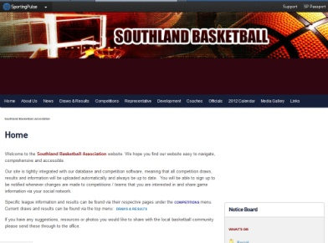  COMMUNICATIONS & MARKETING | DEVELOPMENT | FACILITIES | COMPETITIONS | FRANCHISE &  REPRESENTATIVE
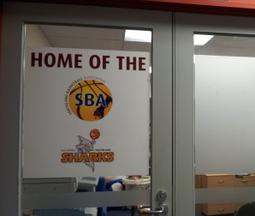  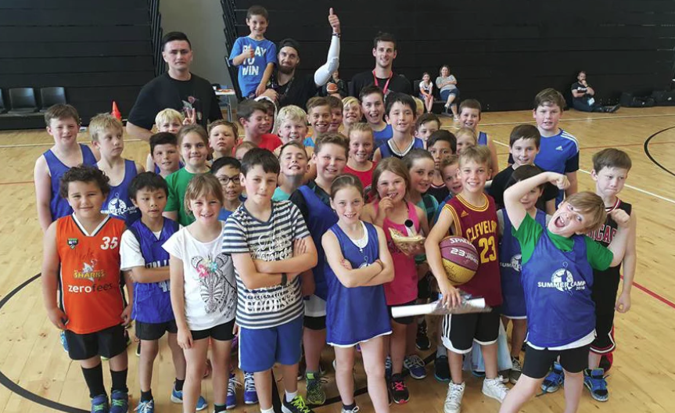 |  | 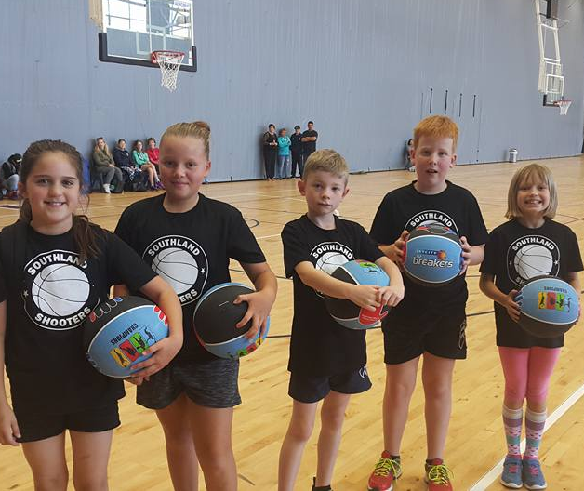 | 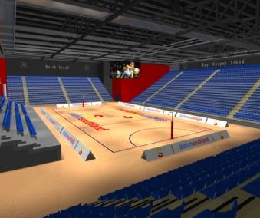 |  | 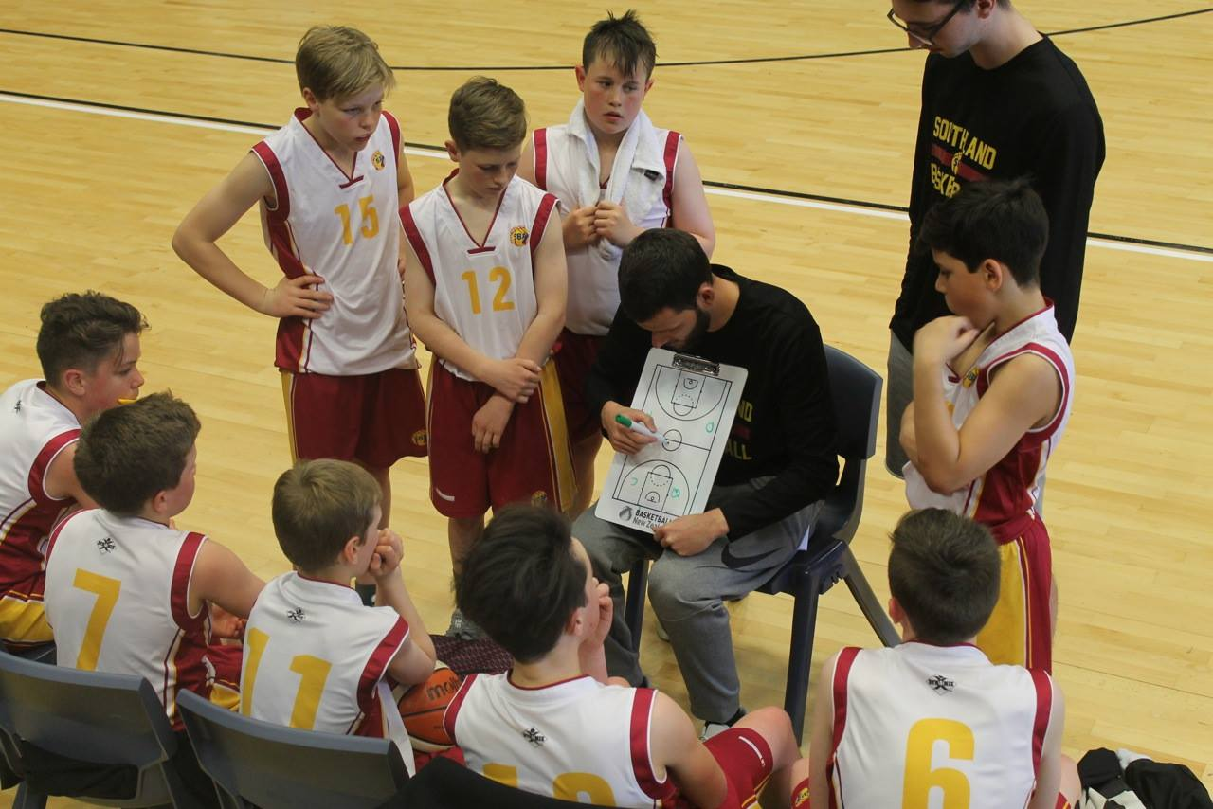
Strategic Initiatives  - Attract and retain the best people to govern, lead, promote and deliver to achieve our vision  - Develop and maintain partnerships to offer or receive expertise, resources and assistance.  - Provide career and personal development opportunities for our staff and volunteers  - Identify and increase our volunteer base | Strategic Initiatives  - Ensure best practice policies and procedures are incorporated and reviewed.  - Identify, plan and secure funding for operational needs over the next 3-5 years  - Maintain effective relationships with new and existing clubs, schools, sponsors, funders and other key stakeholders  - Identify and manage assets  - Develop mutually beneficial relationships with like organisations and other successful sporting / business models | Strategic Initiatives  - Develop marketing and advertising strategies that enhance the profile of Southland Basketball  - Embrace changing methods of communication to maximise reach to new audiences  - Effective database management for communications within the wider community  - Seek regular feedback that enables us to provide meaningful information and improvement to all our stakeholders  - Take advantage of revenue generating activities. | Strategic Initiatives  - Provide high quality coaching and refereeing opportunities  - Implement clear progression and development pathways for players, coaches, managers and administrators  - Develop a strategy for retention of school leavers  - Plan and develop a pathway for the women’s game  - Performance appraisal and development plan is produced for all staff | Strategic Initiatives  - Increase facility usage by a wider basketball community  - Develop a Business Continuity Plan | Strategic Initiatives  - Provide appropriate and innovative competition structures  - Expansion of current existing competitions  - Continue to develop new initiatives to increase participation rate at all levels | Strategic Initiatives  - Continually review talent identification and talent development programmes  - Recognise and reward elite athletes and high achievers  - Enhance working relationship with BBNZ  - Support SHARKS franchise  - Support efficient representative programme

